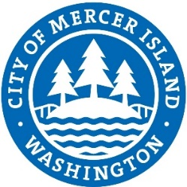

**SOQ, No. 23-31**

**Project:** Sub-basin 46.3a Watercourse Stabilization Design

Due Date:

October 06, 2023 at 2:00 PM

Respondents

|  |
| --- |
| **NAME** |
| Northwest Hydraulic Consultants |