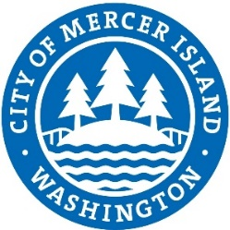

**RFQ, No. 25-07**

**Project:** 76th Avenue SE Mid-Block Crossing and ADA Improvements

**Deadline:**

March 3, 2025 @ 2PM to publicworks@mercerisland.gov

Respondent Ranking

|  |  |
| --- | --- |
| **Engineering Firm** | **Position** |
| Transpo Group | 1 |
| DKS Associates | 2 |